DMS Comm

# Project Charter

**Project Description**

In this project, we want to build an Android app. It could allow users to communicate over different devices, and send shared data. This app increases the communication between people, and share information easily.

**Project Objectives**

* Create an Android application which can improve the communication between people.
* Apply Messaging Service & Near Field Communication technologies from DMS classes to have practical experience in Android development.

**Team Members**

|  |  |
| --- | --- |
| Name | Student ID |
| Caroline Qiu | 1300906 |
| Jiajie Ji | 1127766 |
| Yue Li | 1251124 |

# User case

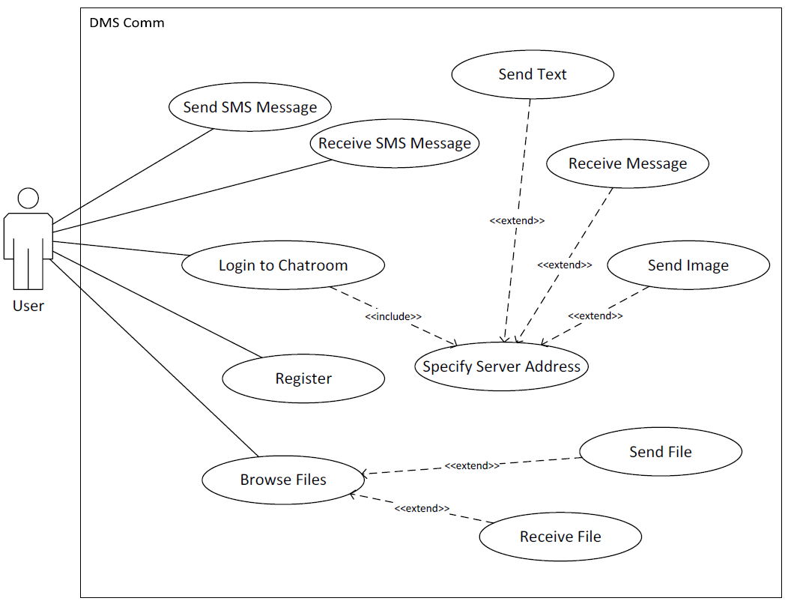

# User Story

1. As a user, I should be able to send message to a phone number.
2. As a user, I should be able to register an account.
3. As a user, I should be able to join a group chat room.
4. As a user, I should be able to specify my name in the chat room.
5. As a user, I should be able to chat with other users in chat room.
6. As a user, I should be able to view my contact list.
7. As a user, I should be able to add users into my contact list.
8. As a user, I should be able to have chat with user from my list.
9. As a user, I should be able to remove users from my contact list.
10. As a user, I should be able to send data to a different user.

# Product Backlog

|  |  |  |  |  |
| --- | --- | --- | --- | --- |
| ID | User Task | Priority | Date |  |
| 3 | Join chat room | 1 | 25.04.2015 |  |
| 4 | Specify chat name | 1 | 27.04.2015 |  |
| 5 | Communicate with chat users | 1 | 27.04.2015 |  |
| 1 | Send text to phone | 2 |  |  |
| 2 | Register | 2 |  |  |
| 6 | View contact list | 2 |  |  |
| 7 | Add user to list | 2 |  |  |
| 8 | Chat from contact list | 2 |  |  |
| 9 | Remove user from list | 2 |  |  |
| 10 | Send data via NFC | 3 |  |  |